**Problem Statement** 1: Jimmy, from the healthcare department, has requested a report that shows how the number of treatments each age category of patients has gone through in the year 2022. The age category is as follows, Children (00-14 years), Youth (15-24 years), Adults (25-64 years), and Seniors (65 years and over). Assist Jimmy in generating the report.

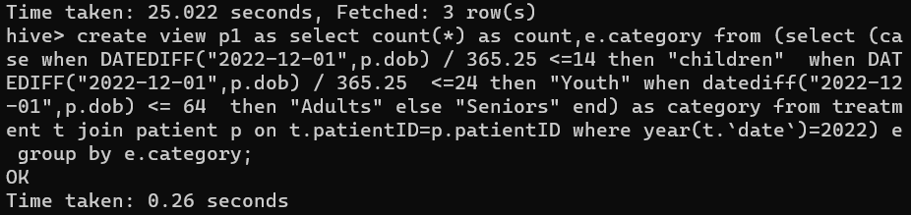







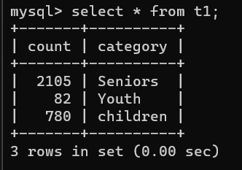

**Problem Statement 2**: Jimmy, from the healthcare department, wants to know which disease is infecting people of which gender more often. Assist Jimmy with this purpose by generating a report that shows for each disease the male-to-female ratio. Sort the data in a way that is helpful for Jimmy.

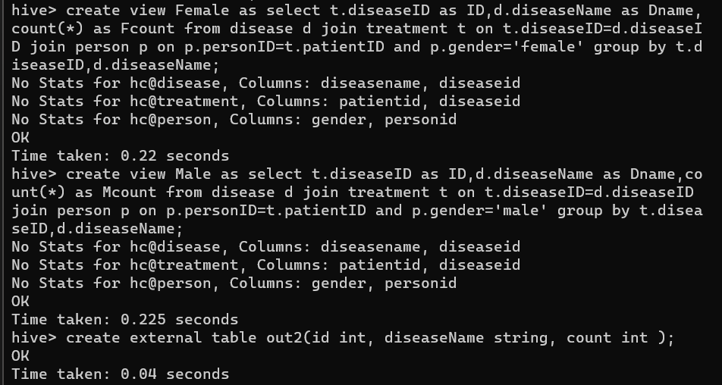

Insert overwrite table out2 select * from Male;

Insert overwrite table out2 select * from Female;



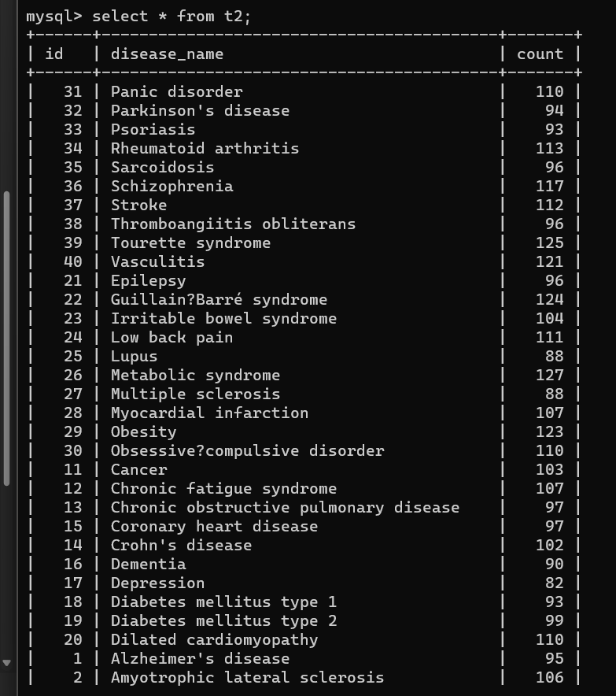

**Problem Statement 3:** Jacob, from insurance management, has noticed that insurance claims are not made for all the treatments. He also wants to figure out if the gender of the patient has any impact on the insurance claim. Assist Jacob in this situation by generating a report that finds for each gender the number of treatments, number of claims, and treatment-to-claim ratio. And notice if there is a significant difference between the treatment-to-claim ratio of male and female patients.

**Solution:**

create view p3 as select p.gender ,count(t.treatmentID) , count(t.claimID) , count(t.treatmentID)/count(t.claimID) from treatment t join person p on t.patientID=p.personID group by p.gender;



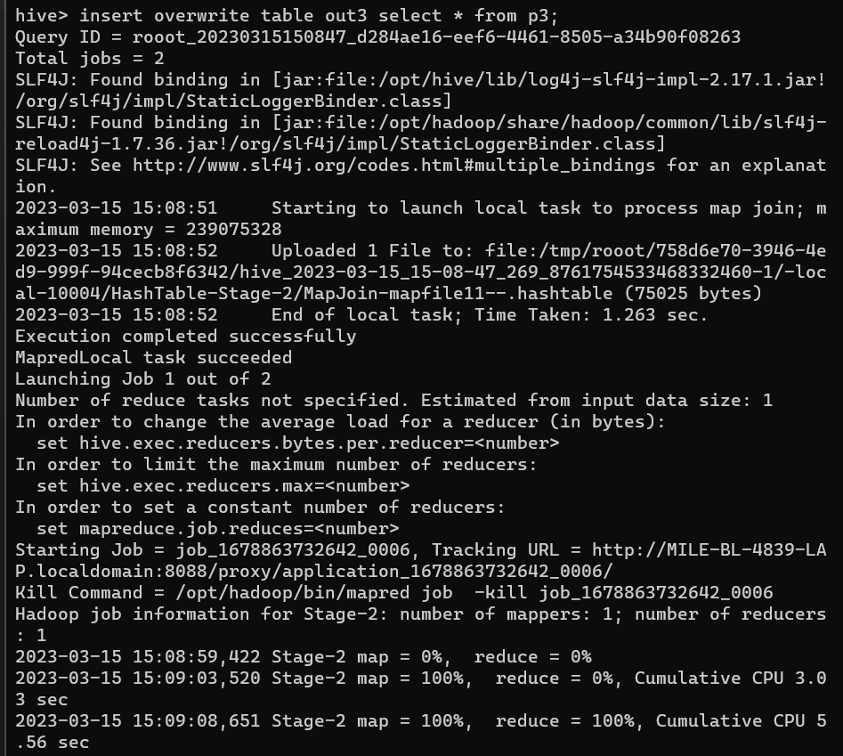



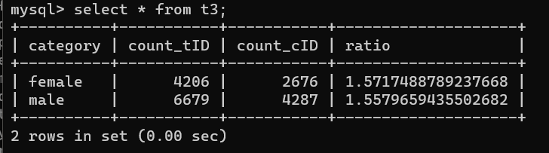

**Problem Statement 4**: The Healthcare department wants a report about the inventory of pharmacies. Generate a report on their behalf that shows how many units of medicine each pharmacy has in their inventory, the total maximum retail price of those medicines, and the total price of all the medicines after discount.

Note: discount field in keep signifies the percentage of discount on the maximum price.







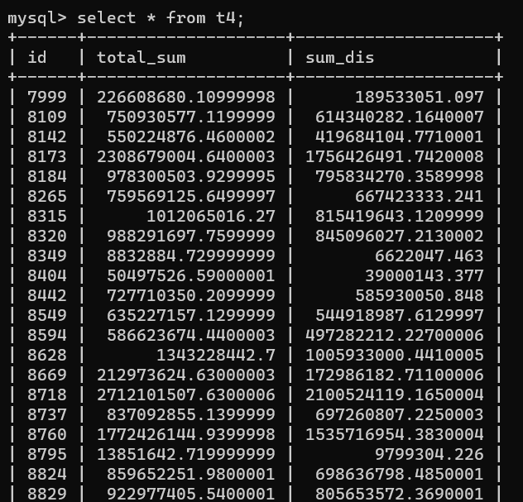

**Problem Statement 5:**  The Healthcare department wants to know which disease is most likely to infect multiple people in the same household. For each disease find the number of households that has more than one patient with the same disease

Note: 2 people are considered to be in the same household if they have the same address.

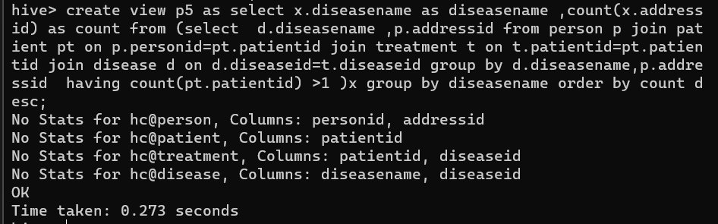







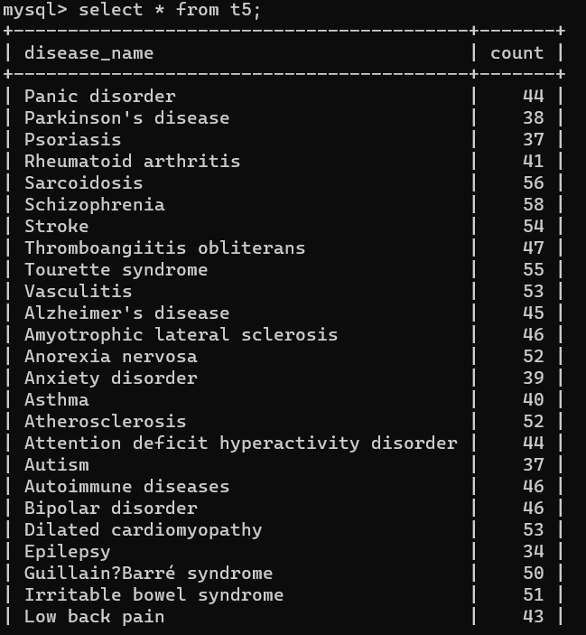

**Problem Statement 6**: Insurance companies want to assess the performance of their insurance plans. Generate a report that shows each insurance plan, the company that issues the plan, and the number of treatments the plan was claimed for.







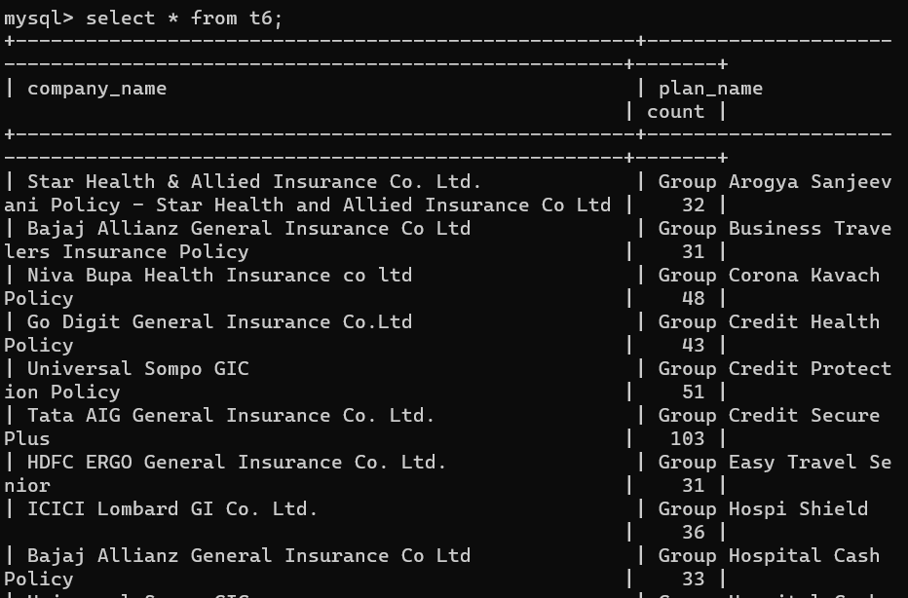

**Problem Statement 7**: Johansson is trying to prepare a report on patients who have gone through treatments more than once. Help Johansson prepare a report that shows the patient's name, the number of treatments they have undergone, and their age,Sort the data in a way that the patients who have undergone more treatments appear on top.

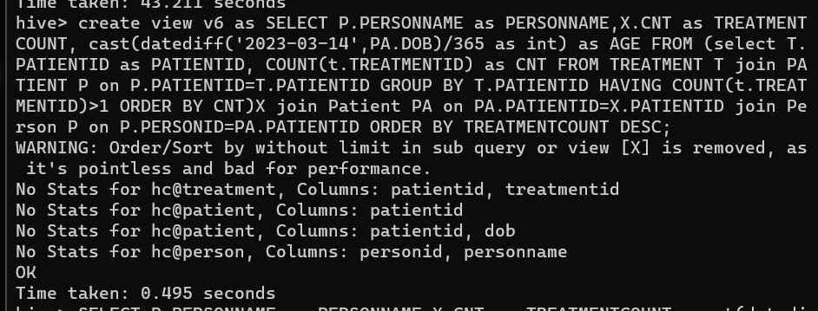







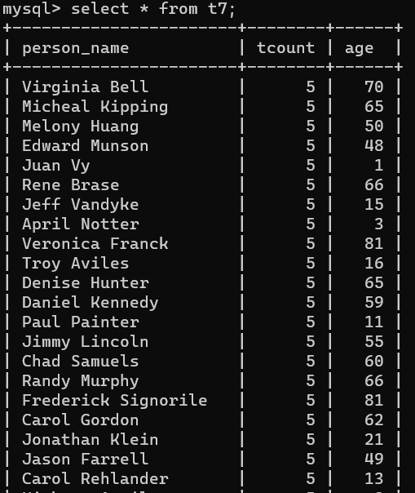

**Problem statement 8:** The State of Alabama (AL) is trying to manage its healthcare resources more efficiently. For each city in their state, they need to identify the disease for which the maximum number of patients have gone for treatment. Assist the state for this purpose.

Note: The state of Alabama is represented as AL in Address Table.



